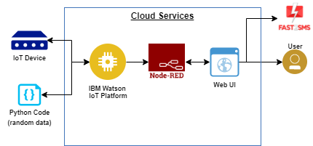Team ID : PNT2022TMID31860



PROPOSED SOLUTION

**To Monitor the water parameters such as Turbidity, Conductivity, salinity, pH, dissolved solvents and to analyse the quality of River Water.**

**Monitoring water parameter like Sensors and Control measures by ultrasonic frequencies.**

**TOC Sensor based water parameters monitoring which identifies biological and chemical changes in water.**

**The model could be scaled according to size of the water body about to be tested.**

**The monitoring system could be sold in the market for the purpose of testing water quality**

It provides the user with an idea about the quality of river water which might help them to base the usage of the water according to its quality.